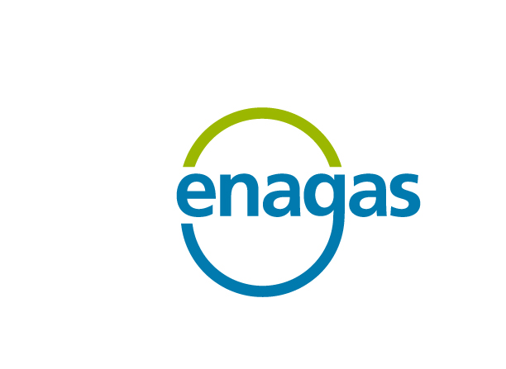

ACER pre-consultation on “Energy Regulation: A bridge to 2025”

Enagás comments



17th December 2013

Overall assessment and summary of recommendations
Enagás welcomes the opportunity to contribute to ACER’s preliminary thoughts on the period to 2025.
Enagás considers that ACER’s overall approach is essentially right, and does not have any major concerns on the foundations of the policy to Bridge to 2025. Though the initiative, in the case of natural gas, significantly overlaps with the potential review of the Gas Target Model, it allows for strengthening the overall consistency of European energy policy, and comes at the right time.
In particular, it is of interest that the interactions between gas and electricity are being identified, as well as the changing role of natural gas in the current and foreseen context, and that there is a genuine intention to address these issues through concrete measures, rather than providing a mere description of them. This has not always been the case in the formulation of previous policies.
On the field of natural gas, Enagás’ comments to ACER pre-consultation focus on the interaction between gas and electricity, the GTM, infrastructure development and, particularly, on hub liquidity and market integration. The following recommendations and findings can be highlighted:
- A common electricity and gas day should be implemented. Since it is late to change the gas day approved in the NC on CAM, it should be explored whether electricity procedures could be adapted to gas markets.
- “Copied and pasted” solutions from the electricity market might not be practicable. This is the case of market coupling.
- There is merit in periodically reviewing and updating the model and Enagás fully supports the new GTM process.
- A harmonised methodology for the calculation of the churn rate should be developed, to help assessing the fulfilment of the general criteria established in the GTM.
- The reviewed GTM should also explore into the possibility of recommending a European wholesale supplier licence to book capacity at intra-EU IPs, which would be consistent with the GTM original idea of fostering gas trades at hubs and not at borders.
- Hubs development is likely to remain the pending subject of market integration if further actions are not adopted. The apparent success of day-ahead price-convergence in the NWE area should be assessed against the failure of most hubs in the NWE area to achieve a sufficient degree of liquidity, the remaining network constraints, the fact that in most of European countries outside the NWE hubs are either illiquid or inexistent, and the general failure to develop forward and future markets.
- It is essential that virtual trading points are deep and liquid. The stability of price convergence in the long term, while some physical constraints remain, is to be proved. The degree of price convergence in 2013 has been lower than in 2012. The possibilities of peripheral countries to ever achieve the same degree of price alignment as the hubs in the NWE limited.
- Infrastructure development remains key to ensure market integration. In order to facilitate market integration, apart from the overall CBA, the CBA should be independently performed in each country, and if individually passed in all of them, the investment should be made without requiring further discussions on cost allocation. This should be true for mechanisms under both “Incremental capacity” and for “Open Seasons”. The Gas Target Model could provide guidelines on this.
- In cases where the overall CBA is passed but not all the individual CBAs, discussions between NRAs should include the allowed revenues framework and the effective and allowed infrastructure costs. Otherwise, consumers in one country will be asked to pay for some allowed revenues to a TSO in another country whose underlying costs have not been assessed by the regulator in charge of protecting their interests.

Interaction between gas and electricity
It is of interest that the interactions between gas and electricity are being identified, as well as the changing role of natural gas in the current and foreseen context. This has not always been the case in the formulation of previous policies.
For example, voices from regulators and TSOs in the Iberian Peninsula alerting that some inefficiencies could be introduced by establishing a common gas day in Europe while ignoring the benefits of having a common day for electricity and gas (as was already the case in Iberian markets), were largely ignored. With the implementation of Network Codes, CCGTs will now be exposed to significantly different gas and electricity days, making it more difficult to balance their inputs and offtakes, or reducing their opportunities to provide flexibility. This issue could have been successfully addressed some 2 or 3 years ago at European level, adapting the NC on CAM for gas; now, with the Network Code already approved and under implementation, it might be very complex to arrive to a solution, at a time when it is of utmost importance to ensure coordination between both markets for the provision of flexibility. It should be explored whether electricity procedures could be adapted to gas markets.
Though there are several aspects of economic regulation which are common to gas and electricity, from the physical point of view these energies are rather distinct. This should be taken into account when designing detailed regulations to foster market integration. The fact that there is more experience on the integration of electricity market poses the risk that solutions that have worked for them are “copied and pasted” in gas markets, where they might not be practicable. This is the case of market coupling.

Gas Target Model
Enagás fully supports the initiative to potentially review the GTM. While several voices have been raised against such review before the full implementation of network codes, Enagás sees merit in periodically reviewing and updating the model, if only to conclude that it is not yet necessary to modify any essential aspect.
The criteria established to define a market as liquid have received harsh criticism for a lack of technical justification though, in the opinion of Enagás, they are roughly adequate if understood as guidelines or indicators. Some fine tuning would be of help, in particular in the case of the calculation methodology of the churn rate, for which there are various potential options that deliver slightly different values. A harmonised methodology for its calculation should be developed.
Enagás firmly believes that the GTM is right in anticipating that a number of Europe’s current entry/exit zones will require mergers (under whatever model) to achieve a sufficient degree of liquidity.
The reviewed GTM should also explore into the possibility of recommending a European wholesale supplier licence to book capacity at intra-EU IPs. This would ensure that the same company that has been allocated capacity, identified by a single EIC code, is the one signing the contract with both TSOs, and thus gas transactions are not made at the border, as is still the case nowadays. The company holding the European wholesale supply licence could afterwards transfer the natural gas to an affiliate, or to any other company, within each system. This would be fully consistent with the original formulation of the GTM, fostering trading at hubs.

Hub liquidity, market integration and price convergence
There is some overenthusiasm about the success of day-ahead price-convergence in the NWE area, recently showed by the OIES study. The truth is that most of hubs in the area remain insufficiently liquid, some potential network constraints are not observable due a reduced level of demand (which could be temporary), and in most of European countries outside the NWE hubs are either illiquid or inexistent. There is also a need to further develop forward and future markets there where day-ahead markets are already delivering acceptable results.
While development and implementation of network codes is progressing satisfactorily, hubs development is likely to remain the pending subject of market integration if further actions are not adopted.
Under the original GTM formulation, it is essential that every virtual trading point is deep and liquid, since hubs are thought to operate in balancing zones of optimal size. Stakeholders advocating for a situation where only a few hubs are liquid and the rest are traded on a basis differential have in mind that small, adjacent markets will remain in place and will not be merged even when there are not capacity restrictions between them, but only regulatory and legal hurdles.
To this regard, an analogy with the American market cannot be drawn. First, on the American market, hubs have appeared as a consequence of market dynamics, and not as part of a predefined plan achieve a particular market design. They appear and disappear in response to market changes.
Therefore, while hubs may be traded on a basis differential, all of them enjoy a fair degree of liquidity. And because markets are dynamic, those differentials are not even stable; in fact they are volatile in the short-term and may change of sign in the mid-term.
On the contrary, in Europe hubs are somehow “politically driven” and liquidity is not guaranteed. Neither will price differentials, at least in the case of peripheral countries, be constant if anomalies occur.
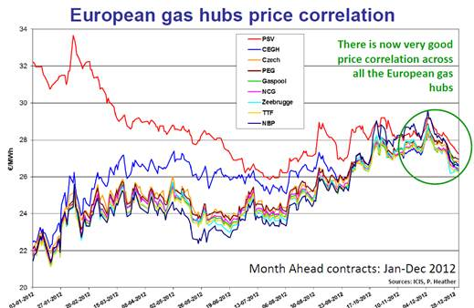
Though there is now a good correlation between hubs in the NWE region, including also the Italian hub, the stability of price convergence in the long term, while some physical constraints remain, is to be proved. For example, price convergence in the case of Italy has been helped by the reduction of demand, since no new infrastructures have been completed. Notably, the OIES does not cover 2013 (though it mentions some events that took place in Feb 2013). When we have a look at 2013 some concerns arise.
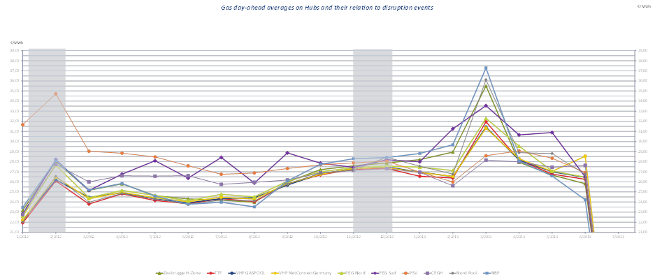
The possibilities of peripheral countries to ever achieve the same degree of price alignment as the hubs in the NWE limited. The importance of liquidity is underestimated, in a context where, as the OIES study also mentions, anomalies occur due to either hub immaturity or physical connectivity constraints. Price convergence is clearly insufficient if not fully guaranteed (and it will not be guaranteed if physical constraints remain); in case of anomalies, areas with non-liquid markets would have an unreliable price reference, and subject to potential manipulation.
While not a comparable case due to the lack of physical connection, some analysts though that the remarkable price convergence achieved between Henry Hub and the Bristish NBP thanks to LNG in the period from Feb 2009 to Feb 2010 would remain. In 2010 the market realised again that physical constraints are still there when market dynamics change.

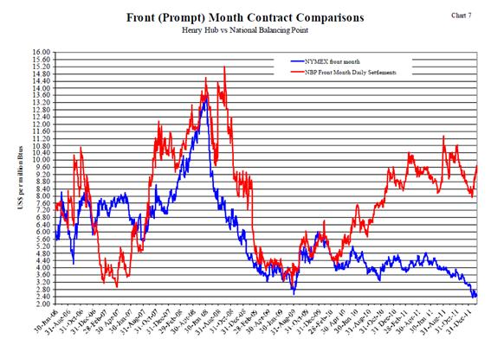
In summary, as regards peripheral countries, we should be cautious about price convergence and place the right importance to developing liquidity in each single market.
Infrastructure development remains key to ensure market integration. In Spain price convergence with the NWE area has not occurred due to physical constraints. Price differentials, which were lower in the past (though not observable until an organised hub is set), are now high, and in any case not constant (the same happens between PEG Nord and PEG Sud in France, being the second rather illiquid).

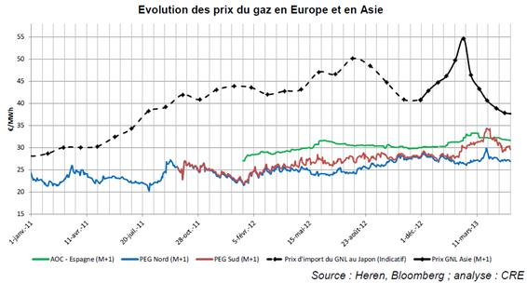

Infrastructure development
Infrastructure development is key for peripheral countries to be part of the European energy market. Recent initiatives include the development of Cost-Benefit analysis for applying mechanisms that facilitate the development of such infrastructures.
However, when a CBA is positive for an infrastructure, there is no assurance that the infrastructure will be developed.
Enagás view is that the CBA should be independently performed in each country, and if individually passed in all of them, in order to facilitate market integration, the investment should be made without requiring further discussions on cost allocation. This should be true for mechanisms under both “Incremental capacity” and for “Open Seasons”. The Gas Target Model could provide guidelines on this.
If the CBA is not passed in a particular country but the overall CBA is positive, discussions on Cross Border cost Allocation should take place. However, in those cases discussions will be incomplete if they are limited to allocating costs according to the CBA. The allowed revenues framework and the effective and allowed infrastructure costs should also be part of the discussion. Otherwise, consumers in one country will be asked to pay for some allowed revenues to a TSO in another country whose underlying costs have not been assessed by the regulator in charge of protecting their interests.

While Enagás shares the view that substantial progress has already been made towards the internal energy market in the NWE region in terms of price convergence amongst the major gas hubs, the OIES paper lacks some econometric muscle to really make the point.
For example, the US Energy Information Agency informs that “By 1998, 36 market centers had been established within the U.S. natural gas pipeline grid. By 2003, however, 13 of these had closed their doors as the concept matured and those that were unable to develop a trading base were eliminated.” For more information see “Natural Gas Market Centers: A 2008 Update”, available at http://www.eia.gov/pub/oil_gas/natural_gas/feature_articles/2009/ngmarketcenter/ngmarketcenter.pdf)
For example, forward market prices for natural gas this Autumn 2013 indicate that the spot price of natural gas at the TCO Appalachia trading point will go below the benchmark Henry Hub price early next year. See http://www.eia.gov/todayinenergy/detail.cfm?id=13331).

